**DIGITAL SIGNAL PROCESSING LAB**

**Fall 2024, 5th Semester**

**Lab Report 9**



# Submitted by: **Hassan Zaib Jadoon**

Registration Number**: 22PWCSE2144**

Section: **A**

“On my honor, as a student at the University of Engineering and Technology

Peshawar, I have neither given nor received unauthorized assistance on this academic work.”

Signature:

**Submitted To: Dr. Yasir Saleem Afridi**   
**Department of Computer Systems Engineering**  
**University of Engineering and Technology Peshawar**

**CSE 402L: Digital Signal Processing**

|  |  |  |  |  |
| --- | --- | --- | --- | --- |
| **Demonstration of Concepts** | **Poor (Does not meet expectation (1))**  The student failed to demonstrate a clear understanding of the assignment concepts | **Fair (Meet Expectation (2-3))**  The student demonstrated a clear understanding of some of the assignment concepts | **Good (Exceeds Expectation (4-5)**  The student demonstrated a clear understanding of the assignment concepts | **Score**  **30%** |
| **Accuracy** | The student completed ( <50%) tasks and provided MATLAB code and/or Simulink models with errors. Outputs shown are not correct in form of graphs (no labels) and/or tables along with incorrect analysis or remarks. | The student completed partial tasks (50% - <90%) with accurate MATLAB code and/or Simulink models. Correct outputs are shown in form of graphs (without labels) and/or tables along with correct analysis or remarks. | The student completed all required tasks (90%-100%) with accurate MATLAB code and/or Simulink models. Correct outputs are shown in form of labeled graphs and/or tables along with correct analysis or remarks. | **30%** |
| **Following Directions** | The student clearly failed to follow the verbal and written instructions to successfully complete the lab | The student failed to follow the some of the verbal and written instructions to successfully complete all requirements of the lab | The student followed the verbal and written instructions to successfully complete requirements of the lab | **20%** |
| **Time Utilization** | The student failed to complete even part of the lab in the allotted amount of time | The student failed to complete the entire lab in the allotted amount of time | The student completed the lab in its entirety in the allotted amount of time | **20%** |

**Lab Report:** **Frequency Division Multiplexing and De-multiplexing**

**Step 1: Load and Play Voice Signals**

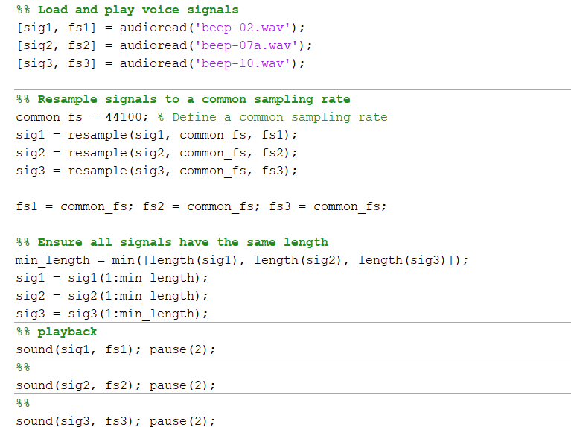

Remarks:

Step II: Plot the spectra of the signals as they arrive (Use fft and dsp.SpectrumAnalyzer  for comparison)

Code:

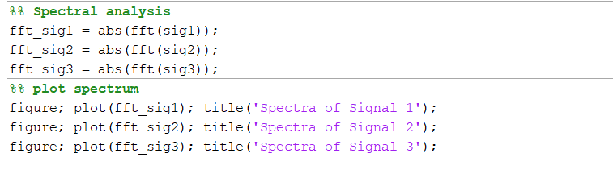

Output:

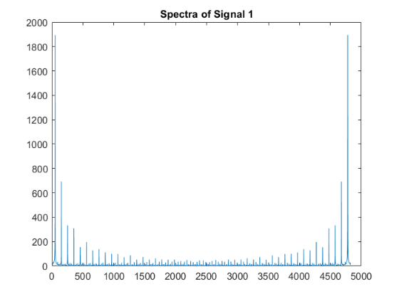

Remarks:

Step III: the signals are passed through a low pass filter and plotted

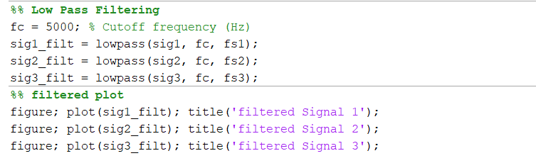

Output:

|  |  |  |
| --- | --- | --- |
|  |  |  |

Remarks:

STEP IV: Reproduce the signals after passing them through the filter.

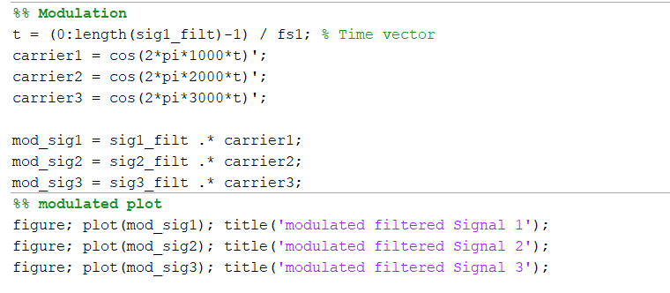

Output:

|  |  |  |
| --- | --- | --- |
|  |  |  |

Remarks:

STEP 6: The modulated signals are filtered in the given band and added together

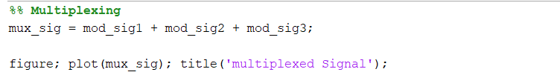

Output:

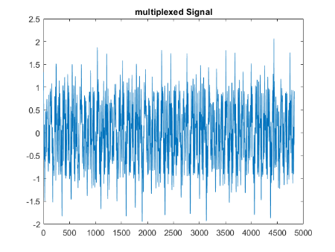

Remarks:

STEP 7, some noise is added to the transmitted signal

Output:

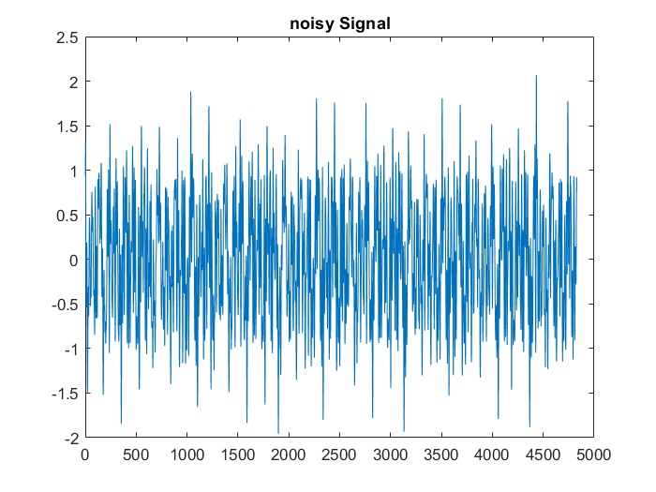

Remarks:

STEP 8, upon arrival each band is filtered

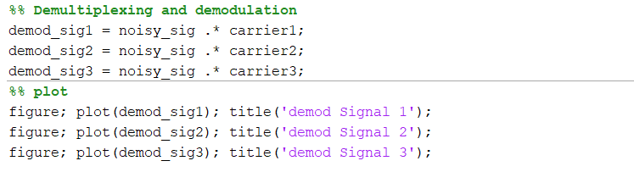

Output:

|  |  |  |
| --- | --- | --- |
|  |  |  |

Remarks:

STEP 9, each recovered band is demodulated to return the signal at the indicated frequency

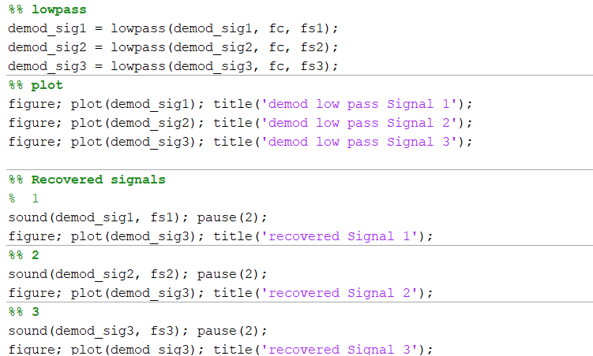

Output:

|  |  |  |
| --- | --- | --- |
|  |  |  |

Remarks: